 | R V College of Engineering  Department of Computer Science and Engineering  CIE - II: Question Paper
Subject :  (Code) | Compiler Design (CS363IA) |  |  | Semester : 6th BE
Date : 5/06/2025 |  | Duration : 120 minutes | Staff : DD/SB/SNM/SMS/PK
Name : |  | USN : | Section : A,B,C,D,ISE

Si.No | Questions | M
1. | Differentiate between kernel and non-kernel items. List the Kernel and non-kernel items of the production A→XYZ | 2
1. Kernel items: the initial item, S' →.S and all items whose dots are not
at the left end.
2. Nonkernel items: all items with their dots at the left end, except for
S' →.S 1M
A→.XYZ
A→X.YZ
A→XY.Z
A→XYZ. 1M
2 | I₁₀ = X→YZ.  X→.aX  X→.b  Is there any conflicts in the LR(0) paring table for the above state. If Yes mention the type of conflict | 2
Yes. 1M
The i/p columns a,b shift and reduce entries will be in the parimg table for the state I_{10 1M}
3 | What is handle pruning? Give Example  Bottom-up parsing during a left-to-right scan of the input constructs a right-  most derivation in reverse. Informally, a "handle" is a substring that matches  the body of a production, and whose reduction represents one step along the  reverse of a rightmost derivation. A rightmost derivation in reverse can be obtained by handle pruning."  Handle pruning is the process of: Identifying a handle in the current string (from stack , remaining input), Reducing it with the corresponding left-hand side non-terminal, and Repeating this until the start symbol is obtained. 1M  Example 1M | 2
4 | Consider the Grammar with Productions ( A→BC, B → , C →digit C , C → } with the following SDD , Find the value of A.a for the input 1 2 3 and also find the type of the attribute c and d  A→BC C.c = B.b  A.a= C.d  B → B.b = digit.lexval  C →digit C₁ C₁.c = digit.lexval + 1+ C.c  C.d = C₁.d  C → C.d=C.c | 2
c is inherited attribute
d is synthesized attribute 1 M
A.a =13 1M
5. | __________________ is the more power LR parser | 1
 | CLR
6. | ___________________ is the portion of the store(memory) that is used for data that can live indefinitely or until the program deletes it explicitly | 1
 | Heap
1. | Consider the following grammar:  S→ AaBb| BbAa  A→aA|  B→bB|  - Compute the canonical collection of LR(0) itemsets.  - Construct the SLR Parsing Table  - Check whether the grammar is SLR(1) or not? Give reason | 10
LR(0) Automata 4M
Parsing table 4M
Final answer with Justification 2M
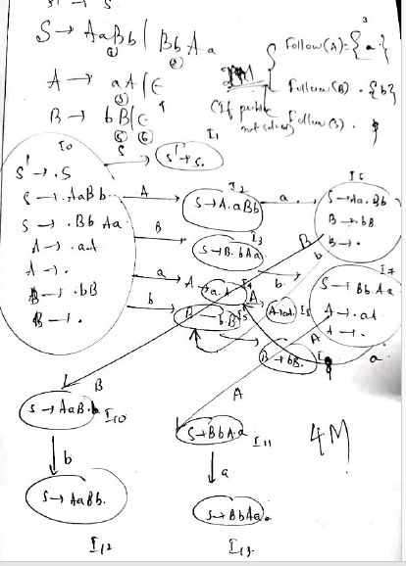 | 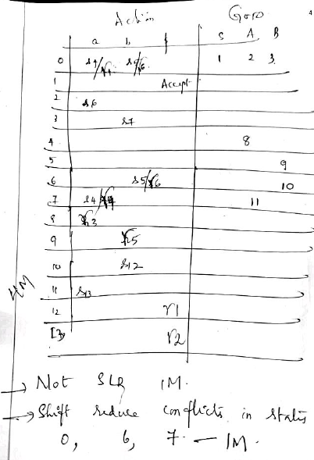

2. | Consider the following ambiguous grammar:  S→L=R | R  L→*R | id  R→ b  - Construct the Canonical LR sets of items for the grammar  - Show the parsing table for CLR and LALR  - State whether the grammar is CLR or LALR. Justify your answer. | 10
LR(1) Automata 4M
CLR Parsing table 3M
LALR Parsing Table 1M
Grammar is CLR and LALR as no conflicts. 2M
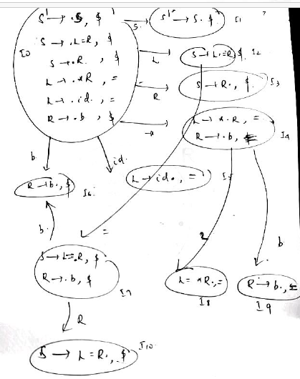
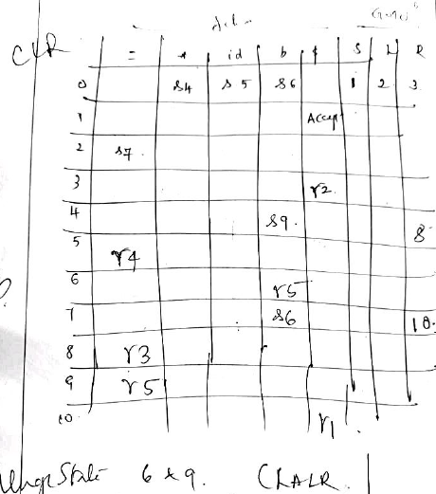 | 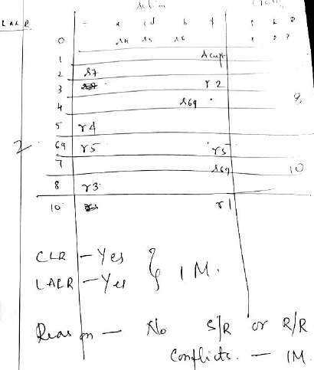

3 a. | What is syntax directed definition? Differentiate between Synthesized attribute and Inherited attribute. Give Example  Difference 3M  Synthesized attribute : for a nonterminal A at a parse-tree node N is defined by a semantic rule associated with the production at N. Note that the production must have A as its head. A synthesized attribute at node N is defined only in terms of attribute values at the children of N  and at N itself.  Inherited attribute :for a nonterminal B at a parse-tree node N is defined by a semantic rule associated with the production at the parent of N. Note that the production must have B as a symbol in its body. An inherited attribute at node N is defined only in terms of attribute values  at N's parent, N itself, and N's siblings  Example : 2M | 05
b | What are Displays? Explain. | 5
One problem with the access-link approach to nonlocal data is that if the nesting depth gets large, we may have to follow long chains of links to reach the data we need. A more efficient implementation uses an auxiliary array d, called thedisplay, which consists of one pointer for each nesting depth. 2M
Explanation with example 3M
4. | Give the Semantic rules (SDD) for evaluating expression with the following CFG.  T→F T'  T'→*F T'  T'→  F→digit  Give the annotated parse tree with the evaluation order to evaluate the expression 3*5*10 | 10
SDD 4M
Annotated Parse Tree 3M
Evaluation Order 3M
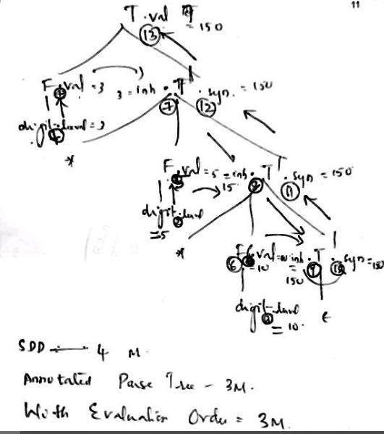

5 a. | What is activation record? Explain the structure of a general activation record. | 5
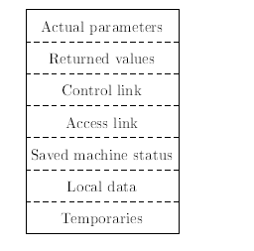Structure 2M
What + Strictute Explanation 3M

Procedure calls and returns are usually managed by a run-time stack called the control stack. Each live activation has an activation record (sometimes called a frame) on the control stack, with the root of the activation tree at the bottom, and the entire sequence of activation records on the stack corresponding to th epath in the activation tree to the activation where control currently resides.
The latter activation has its record at the top of the stack
kinds of data that might appear in an activation record
1. Temporary values, such as those arising from the evaluation of expressions, in cases where those temporaries cannot be held in registers.
2. Local data belonging to the procedure whose activation record this is.
3. A saved machine status, with information about the state of the machine just before the call to the procedure. This information typically includes the return address (value of the program counter, to which the called procedure must return) and the contents of registers that were used by
the calling procedure and that must be restored when the return occurs.
4. An \access link" may be needed to locate data needed by the called procedure but found elsewhere, e.g., in another activation record. Access links are discussed in Section 7.3.5.
5. A control link, pointing to the activation record of the caller. 6. Space for the return value of the called function, if any. Again, not all0called procedures return a value, and if one does, we may prefer to place that value in a register for eefficiency.
7. The actual parameters used by the calling procedure. Commonly, these values are not placed in the activation record but rather in registers, when possible, for greater efficiency. However, we show a space for them to be completely general..
b. | Explain with an example how “access links“ can be used to access non-local data | 5
Purpose :2M
Explanation with example 3M

